LANDIS-II

Climate Library v5.0

User Guide

Melissa S. Lucash

John W. McNabb

University of Oregon

Last Revised: July 8, 2025

# Table of Contents

1 Introduction 3

1.1 Interface between the Climate Library and Succession 4

1.2 Major Releases 4

1.2.1 Version 5.0 (August 2024) 4

1.2.2 Version 4.0 (February 2019) 5

1.2.3 Version 3.0 (September 2018) 5

1.3 Minor Releases 5

1.3.1 Version 4.2 (March 2021) 5

1.3.2 Version 4.1 (June 2020) 5

1.4 Acknowledgments 5

2 Climate Library Configuration File 6

2.1 LandisData 6

2.2 ClimateTimeSeries (Future climate data) 6

2.2.1 Monthly_AverageAllYears 6

2.2.2 Monthly_RandomYears 6

2.2.3 Monthly_SequencedYears 7

2.2.4 Daily_AverageAllYears 7

2.2.5 Daily_RandomYears 7

2.2.6 Daily_SequencedYears 8

2.3 ClimateFile 8

2.4 SpinUpClimateTimeSeries 9

2.5 SpinUpClimateFile 9

2.6 GenerateClimateOutputFiles 9

2.7 UsingFireClimate 9

2.8 FineFuelMoistureCode 9

2.9 DuffMoistureCode 9

2.10 DroughtCode 9

2.11 FirstDayFire 10

2.12 LastDayFire 10

2.13 Atmospheric Pressure 10

3 Climate Input Files 10

4 Climate Output Files 11

4.1 Climate-spinup-input.csv 11

4.2 Climate-future-input.csv 12

4.3 Climate-annual-log.csv 13

5 Example Inputs 14

5.1 Main Climate Configuration (“Climate Config”) File 14

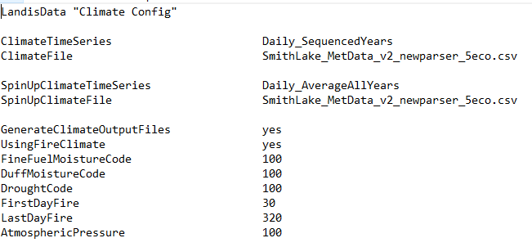 14

5.2 Climate Input File 14

# Introduction

This document describes the climate library for the LANDIS-II model. For information about the LANDIS-II model and its core concepts including succession, see the *LANDIS‑II Conceptual Model*

*Description.*

The role of the climate library is to create a central repository of climate data so that all the model extensions will ‘feed’ off of the same stream of climate.

The library can directly utilize any daily or monthly climate data. The climate data will need to be aggregated to the fundamental climate unit of LANDIS-II (e.g. either the climate region in NECN and DGS or the ecoregion in PnET succession) and then delivered to LANDIS-II as either monthly or daily for the requested time period in a common format (comma delimited with a header). These data will be read into a new climate library (a sharable body of code) that will perform all necessary pre-processing for all climate-dependent LANDIS-II extensions.

Each LANDIS-II extension requires slightly different climate data inputs; the succession extension will serve as the nominal controller of the climate library (activating it with necessary input file(s)). Such deep integration across ecological processes (extensions) allows LANDIS-II to respond to climate in a coordinated fashion at each model time step and allows climate variability to produce realistic emergent properties of species composition, disturbance regimes, and ecosystem dynamics (e.g., carbon cycling). This integration will also facilitate rapid deployment and will minimize the pre-processing overhead typical of many landscape models.

## Interface between the Climate Library and Succession

The Climate Library was designed for any succession extension and has been integrated into NECN, DGS, PnET, and Biomass Succession.

The user specifies an intermediate text file that controls the loading of the climate data. It is similar to the scenario file in that it is the master climate file that specifies which options and which files to use. In the example below, the keyword ClimateConfigFile in the succession input file specifies the climate configuration file for the climate library.

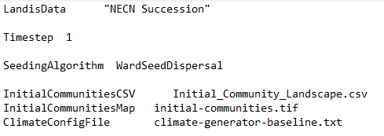

## Major Releases

### Version 5.02 (July 2025)

Added code to make the climate output files optional

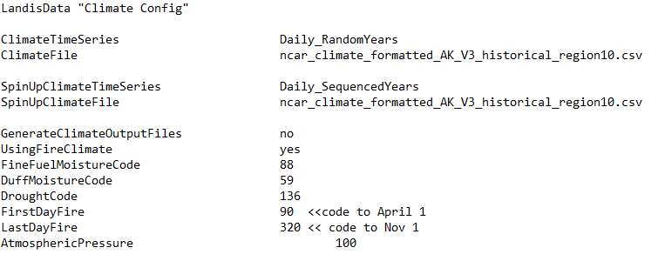

### Version 5.0 (August 2024)

The entire climate library was revised to:

* simplify the code,
* make the units consistent,
* make the climate output files optional,
* make the input file simpler with data in columns, rather than blocks with “trigger words”, and
* eliminate the SD and variance columns which were not used in the previous versions of the climate library for any calculations.

### Version 4.0 (February 2019)

Updated to add min and max relative humidity, PAR, CO2, Ozone and short wave radiation. We also removed the RH slope adjustment factor.

### Version 3.0 (September 2018)

Updated to Core v7.

## Minor Releases

### Version 4.2 (March 2021)

Added PET as an optional input variable. Added FineFuelMoistureCode, DuffMoistureCode and DroughtCode as optional parameters input parameters rather than hard coded in FireClimate.cs. Fixed bug that caused an error in Monthly PET calculations and bug that didn’t allow BeginGrow to be calculated properly if daily data was used. The period to allow the growing season start date to be calculated was extended later in the season to account for our work in boreal ecosystems.

### Version 4.1 (June 2020)

Updated to adjust the wind direction calculation that was incorrect in previous versions. Updated to add average specific humidity, average relative humidity and average temperature as optional parameters in the input file. Now relative humidity can be used directly (without having to provide min and max) and calculated from specific humidity and average temperature. Changed units of SH to be kg/kg rather than g/kg.

## Acknowledgments

Funding for the development of the climate library was originally provided by a USDA AFRI grant.

# Climate Library Configuration File

The text in the climate configuration file must comply with the general format requirements described in section 3.1 *Text Input Files* in the *LANDIS‑II Model User Guide*.

## LandisData

This parameter’s value must be "Climate Config".

## ClimateTimeSeries (Future climate data)

This data is used to specify the options for ‘future’ data, i.e. the climate used during the simulation years of the model (from time=0 until the end of the simulation). It does not include the years required for the “spin-up” period (see section 2.5).

There are six valid values for the ClimateTimeSeries input parameter: Monthly_AverageAllYears, Monthly_RandomYears, Monthly_SequencedYears, Daily_AverageAllYears, Daily_RandomYears, and Daily_SequencedYears. Each one is described below.

### Monthly_AverageAllYears

If the ‘Monthly_AverageAllYears’ option is used, the user will need to supply monthly data in the input file. The climate library will calculate mean monthly temperature and total monthly precipitation **across all years included in the input file.** Then it will use those calculated temperature and precipitation values for each month in each year of the simulation; **this means that the climate will be the same for each year of the simulation.**

### Monthly_RandomYears

If the ‘Monthly_RandomYear’ option is used, the user will need to supply monthly data in the input file. For each year of the simulation, the climate library will randomly select a single year of climate data (with replacement) for each year of the simulation. For example, if the user supplies data for years 2014-2015, the climate library might choose the climate in year 2015 for year 1 of the simulation and year 2014 as year 2 of the simulation.

### Monthly_SequencedYears

If the ‘Monthly_SequencedYears’ option is used, the user will need to supply monthly data in the input file. **The years in the input file will correspond exactly to the years specified for the LANDIS simulation, and they must appear in chronological order.**  For example, if the user supplies climate data for years 2010 to 2015, then the model will run using 2010 as time= 1 in the simulation. Simulation years 2-6 will correspond to years 2011 to 2015 in the input data. If the duration of the simulation exceeds the number of years supplied, the last year of input data will be repeatedly used as climate data until the simulation is complete.

### Daily_AverageAllYears

If the ‘Daily_AverageAllYears’ option is used, the user will need to supply daily data in the input file. **For extensions requiring daily data** (e.g. Dynamic Fire), the climate library will take all the daily data for all the years of the input data and calculate an average of temperature (sum for precipitation) **across all years for each day of the simulation.** Then it will use that **average** (or sum) for each day for each year of the simulation; **this means that the climate will be the same for each year of the simulation.**

**For extensions requiring monthly data** (e.g. NECN), the climate library will take all the daily data for all the years of the input data and calculate an average of temperature (sum for precipitation) **across all years for each month of the simulation.** Then it will use that **average** (or sum) for each month for each year of the simulation; **this means that the climate will be the same for each year of the simulation.**

### Daily_RandomYears

If the ‘Daily_RandomYears’ option is used, the user will need to supply daily data in the input file. The climate library will take all the daily data and calculate an average of temperature (sum for precipitation) for **each month and year.** For each year of the simulation, the climate library will randomly select a single year of climate data (with replacement) for each year of the simulation (see Monthly_RandomYears for more details).

### Daily_SequencedYears

If the ‘Daily_SequencedYears’ option is used, the user will need to supply daily data in the input file. The years in the input file will correspond exactly to the dates specified for the LANDIS simulation, and they must appear in chronological order (see Monthly_SequencedYears for more details).

For extensions requiring daily data (e.g. Dynamic Fire), no additional processing is necessary**.** For extensions requiring monthly data (e.g. NECN), the climate library will calculate an average of temperature (sum for precipitation) **for each month and year of the simulation.**

## ClimateFile

This parameter references the file that contains all the climate data. Minimum temperature, maximum temperature, and precipitation are **required** by the climate library. **The units of temperature are always Celsius and precipitation is always in cm.**

Other parameters are **optional** and include PAR (photosynthetically active radiation), CO2 concentration, ozone concentration, wind speed, wind direction, and nitrogen deposition. Wind direction must be expressed in terms of degrees where the wind is coming from (note this is opposite of the typical convention used by met stations).

These climate parameters can appear in any order in the input file. Details about how to configure the ClimateFile are described in Chapter 3.

## SpinUpClimateTimeSeries

These data are used to specify the options for ‘spin-up’ data, i.e. the climate used during the spin-up phase of the model, and the format closely follows that of the ClimateTimeSeries.

There are six valid values for the ClimateTimeSeries input parameter: Monthly_AverageAllYears, Monthly_RandomYears, Monthly_SequencedYears, Daily_AverageAllYears, Daily_RandomYears, and Daily_SequencedYears. Each one is described above in section 2.2.

## SpinUpClimateFile

This parameter specifies the file that contains all the climate data (Tmin, Tmax and Precipitation) for the spin-up phase of the model. Details about how to configure the ClimateFile are described in Chapter 3.

## GenerateClimateOutputFiles

A Boolean value (yes or no) that indicates whether the climate library will produce climate output logs. If ‘yes’, then the climate library will produce two climate spin-up log files and two future log files.

## UsingFireClimate

A Boolean value (yes or no) that indicates whether the Climate Library should prepare data for calculating Fire Weather Index. If ‘yes’ then the following two parameters are required (springstart and winterstart).

## FineFuelMoistureCode

Seed values to calculate FWI. Original value in the code was 85.

## DuffMoistureCode

Seed values to calculate FWI. Original value in the code was 6.

## DroughtCode

Seed value to calculate FWI. Original value in the code was 15.

## FirstDayFire

Julian day of the earliest possible fire.

## LastDayFire

Julian day of the latest possible fire.

## Atmospheric Pressure

Average atmospheric pressure in kPa. This parameter is optional, used only to convert specific humidity to relative humidity.

# Climate Input Files

Climate data can be obtained from any source.

The user will need to adjust the headers in the climate input file. If the data is monthly, the main columns will be Year, Month, and Variable (e.g. variable name, like MaxTemp. If the data is daily, the main columns will be Year, Month, Day, and Variable.

**The columns that contain the data will have headers that correspond to match the ecoregion names as they appear in the ecoregion.txt file, but they do not need to be in the same order.** If there is an inactive ecoregion, the user should not supply climate data for that ecoregion. The user should list the inactive ecoregion first in the ecoregion.txt file and supply climate only for the active ecoregions.

The user will also need to have the correct variable names. Keep in mind that the words are **not case sensitive**. Wind direction, wind speed and nitrogen deposition data are optional (Table 2).

Table 1. Parameter names, variable names and units needed in climate input file.

|  |  |  |  |
| --- | --- | --- | --- |
| **Parameter** | **Units** | **Variable names** | |
| Maximum  temperature | Celsius | Tmax | maxtemp |
| Minimum  temperature | Celsius | Tmin | mintemp |
| Mean temperature | Celsius | temp |  |
| Precipitation | cm | precip | ppt |
| Wind direction | Degrees (FROM direction) | windDirection |  |
| Wind speed | meters/sec | windSpeed |  |
| Northing wind vector |  | windNorthing |  |
| Easting wind vector |  | windEasting |  |
| Nitrogen deposition | g/m2 | Ndeposition | Ndep |
| Maximum relative humidity | % (i.e. 50 for 50%) | maxRH |  |
| Minimum relative humidity | % (i.e. 50 for 50%) | minRH |  |
| Relative humidity | % (i.e. 50 for 50%) | RH |  |
| Specific humidity | kg/kg | SH |  |
| CO2 concentration | ppm | CO2 |  |
| PAR | µmol/m2/sec | PAR |  |
| Ozone concentration | ppm | ozone | O3 |
| Shortwave radiation | W/m2 | SWR | shortwaveRadiation |
| Potential evapotranspiration | mm/month | PET |  |

# Climate Output Files

When the climate library is run by a succession extension, there will now be four optional output files that contain climate data. A brief description of the files is below.

## Climate-spinup-input.csv

This file lists the temperature and precipitation data that was used during the spin-up phase of the model. This file is useful for making sure that the spin-up climate file was read in properly. **Note that the units are those stored in the climate library; they will be appropriately converted when passed to other extensions.**

***Note: The time step in the Climate-spinup-input.csv file corresponds to the time step in the input file. For example, if you use daily data as your input, then the timestep in the Climate-spinup-input.csv will be daily as well.***

## Climate-future-input.csv

This file lists the temperature and precipitation data that was used during the future phase of the model. If wind speed, wind direction and/or nitrogen deposition were included as inputs, then these will also be provided in this file.

This file is useful for making sure that the ClimateFile read in the data properly. For a detailed description of each parameter in Climate-future-input.csv, the user should open up the Future-Input-Log_Metadata.xml file located in the subfolder called Metadata/Climate-Library.

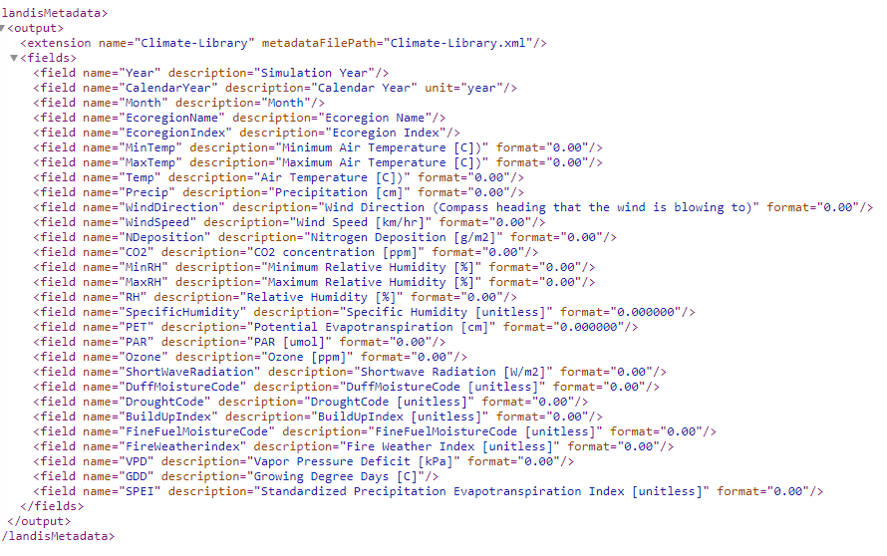

## Climate-annual-log.csv

This file summarizes several climate parameters (e.g. mean annual temperature (MAT), mean annual precipitation (MAP), begin growing season (Julian date)) and Palmer Drought Severity Index (PDSI) on an annual basis for the model run. For a detailed description of each parameter in Climate-annual-log.csv, the user should open up the AnnualLog_Metadata.xml file located in the subfolder called Metadata/Climate-Library.

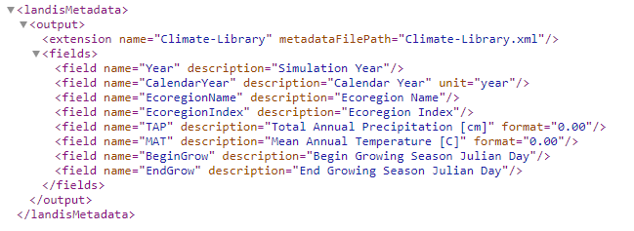

# Example Inputs

## Main Climate Configuration (“Climate Config”) File

## 

## Climate Input File

Columns E-I correspond to the ecoregion names that are specified in the ecoregion.txt file.

